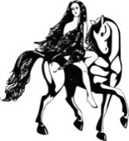 The Empress is Wearing No Clothes
Mary Jo O’Hagan’s Baldwin School District has wasted the generosity of its taxpayers on exorbitant salaries & benefits to its educators.* Nonetheless, Baldwin is in the bottom quartile of Nassau County Schools. Instead of scapegoating New York State, school boards need to clean up their own fiscal ineptitude
Mrs. O’Hagan is a one trick pony. Gimme more money, more money, more money….. gimme, gimme, gimme! Just last spring, she called for a 27% tax increase*. Don’t drink her Kool-Aid… Forget the GAP…. Forget overturning the 2% Cap…. Big Daddy New York is reining in its profligate LI school boards….. Stop the whining about not receiving your fair share. Educators’ excessive salaries and benefits are a sink hole that New York can’t afford to waste additional resources in. Long Island School Board taxes are an embarrassment & detriment to Nassau & Suffolk Counties. New York State can’t print money.
The #1 Job of the NSSBA should be the reforming of the Triborough Amendment. That will help you stand on your own by negotiating your way to solvency. Instead, you whine, complain and practice your scapegoating talking points. For that, Mrs. O’Hagan deserves your crown.
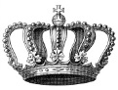
*LEARN MORE….. JUDGE FOR YOURSELF…. . WWW.BALDWINBUDGET.COM
.

