Two Financial Bubbles© 2013
“Housing prices will never go down.” That maxim in the early 2000’s was the basis on which Moody’s gave the packaged Liar’s Loans a AAA rating and sold them abroad. Then more money was pumped into the housing sector. We’re all still suffering the effects of that housing bubble.
The combination of government power and abusive monopolies (Fannie Mae & Freddy Mac) created a financial bubble.
On Long Island, the cost of education is the highest in the nation. Other states don’t pay teachers these exorbitant pay packages, yet they produce well educated young people.
The supersized pay packages on Long Island are a financial bubble. The combination of government power and an abusive monopoly (public education) has produced super elevated salaries & benefits.
“Teachers’ salaries will never go down.” Wrong! Teachers’ salaries can, will and must go down. Salaries are down in the private sector. Profits are down in the private sector. Business is down in the private sector. Why is the government sector immune? Monopoly abuse and government power sustain the exorbitant pay packages.
“Teachers’ salaries will never go down.” That’s what they used to say about the price of a house.
The Rocky Point School District made a serious mistake by signing a long term (10 year) contract with their teachers’ association. It was a brilliant move by the Teachers’ Union. They’ve locked in super elevated salaries for a decade. Brilliant! Not so good for Rocky Point. Another Long Island School Board outfoxed by the teachers’ union. Now the union wants to tout it as a model. Beware of Teachers’ Associations bearing gifts in the form of long term contracts. 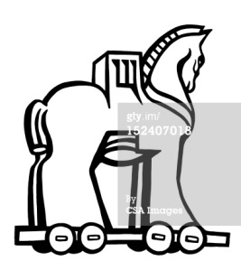
Disclaimer: Educators should earn good salaries, but should not have exceptionally great salaries & benefits. Teachers are wonderful, competent, hardworking, skilled, highly educated, dedicated and caring people with amazing & brilliant union representation that has steamrollered & outfoxed school boards across Long Island.

